Practical 4
Code:https://github.com/bhavyakumar18/DSA/tree/main/Practical%204
Problem 1, I faced problems while inserting a patient at a specific position, especially when the position was at the beginning, end, or greater than the current queue length. I solved this by checking the position before insertion and handling the front and end cases separately. If the position is greater than the current length, the program displays an error message instead of causing a crash.
Output:
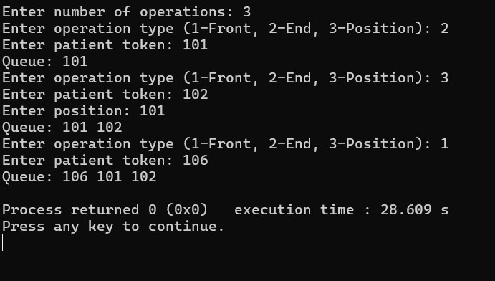
Problem 2, I faced problems while deleting a patient by token and printing the queue in reverse order. I solved deletion by adjusting the links of the previous and next nodes. For reverse printing, I followed the links from the last node toward the first node, so no extra array or storage is required and the original queue is not modified. Another method would be to use a stack, but that would require extra storage.
Output:
